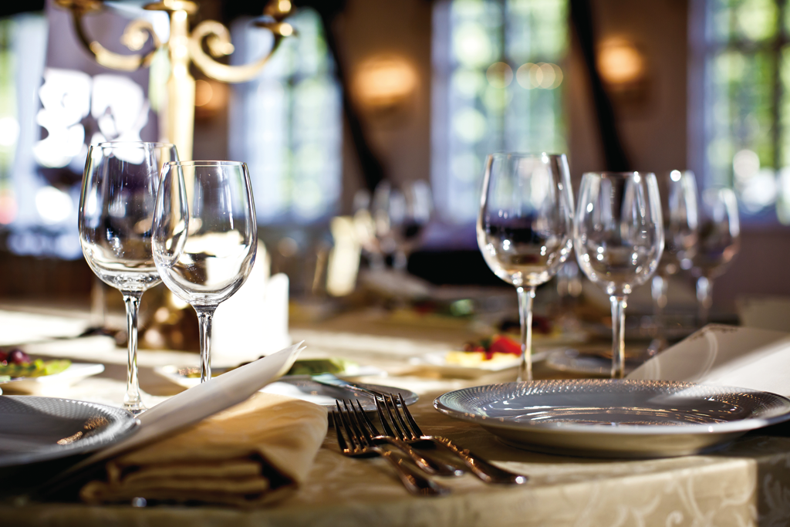
http://www.diamondinyapalace.com/about/
Top 15 Restaurant Savoir Vivre Tips
Savoir Vivre is a set of etiquette rules one has to follow in a specific occasion or a group, for example, at work, at the dinner table, on the phone, at the theater, at the funeral, etc. No matter, how do you look like, how much money you have, if you don’t know what is good manners you will, probably, be disrespected in the eyes of your companions. So, here are 15 main rules of proper behavior at the table and in the restaurant which should be learn and applied in the real life.
- If you were invited for the dinner, before leaving for the restaurant respond to the invitation within 24 hours.
- Men wear a jacket and women wear a gown avoiding shining jewellery. Men should take a hat or a cap off before entering the restaurant. Ladies have no obligations on this point.
- Don’t be late. You can arrive maximum 15 minutes after the appointed time.
- When entering the restaurant man comes in first but inside the restaurant woman goes before man following a host or hostess or maitre d'hotel. When going to have a seat man should help his lady. Also, when ordering a meal, a man chooses after woman.
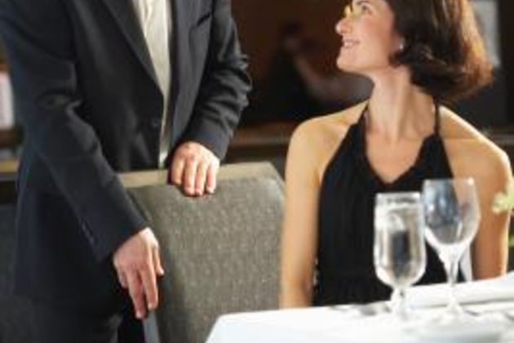
http://www.etaobbs.com/list/manners/
- Don’t start eating until the host or boss (if you are having a business lunch) or lady (on a date) starts first saying “Bon Appetit”.
- When eating take as much time as you need. Don’t fill your mouth with a lot of food. Don’t speak with your mouth full and opened. Try to focus on others, avoid uninteresting or forbidden topics such as money, politics and purchases. Respect your companions; don’t gossip about others, if they are absent.
- Eat your meal taking your utensils from the outside in. First one should use fork for the appetizer which is placed farthest from the plate. When you have already started eatind you should never put your spoon, fork and knife on a table but on the plate.
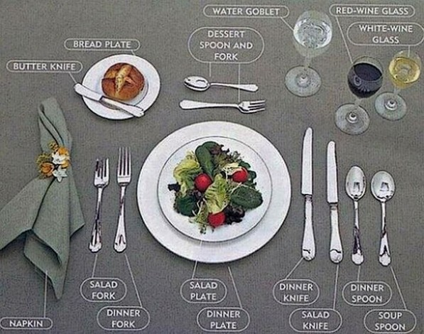
http://magi.triada.bg/somethinkforeveryone.aspx
- Hold your knife in a right hand and a fork in a left hand. 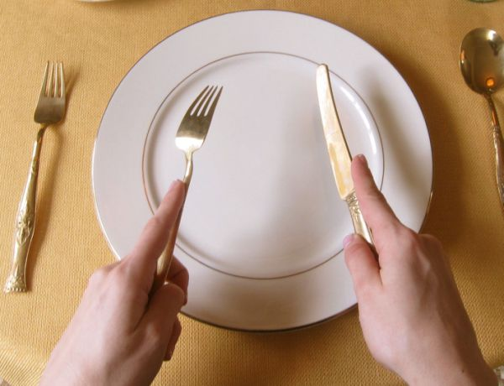
https://in.news.yahoo.com/blogs/foodie/dining-etiquette-055125551.html
- When you are having a soup, a bowl should be tipped away from you.
- Never use your hands to eat, except when taking bread.
- During a dinner a napkin should lay on your lap. If you have to take a little pause, you should place it on the chair. If you are done with your meal, the napkin goes to the left of the plate.
- Don’t place your elbows on the table and avoid slouching.
- Don’t use your phone during a dinner and don’t put it on the table. If you have to pick up, excuse yourself and find another place to talk.
- When served something always say ‘thank you’ and ‘excuse me’ when asking for some item to be passed over.
- Inform the waiter about your plans for the next step of the dinner using your utensils. For example, when you are going to have a pause place your fork and knife on the plate in the position of 8 o’clock and 20 minutes. When you finish with the meal place them in parallel.
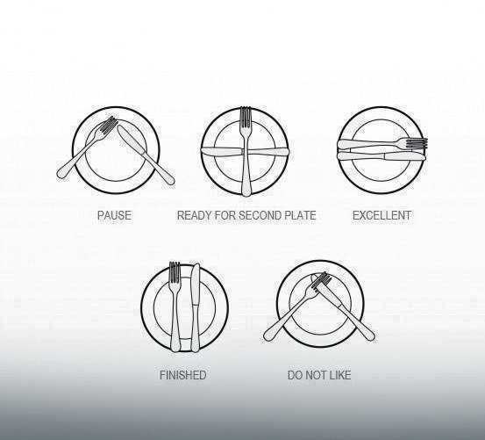
http://kobieta.onet.pl/kulinaria/piec-bledow-ktore-najczesciej-popelniamy-w-restauracji/knb7vs

